Battery

Intro:  
Batteries are an integral component in any electric vehicle, as they provide a portable energy source required for the machine to operate. The battery pack implemented in our design consists of two 6S (6 cell) batteries operating in series to generate a line voltage of 50V, an increase from the 25V specified in the feasibility report. In order to meet the user case requirements, a capacity of at least 360Wh will be required from the battery pack- this will be achieved with lithium polymer batteries of approximate dimension 90x46x158 mm. Maybe talk about commute. Lithium polymer provides superior current supply and lifespan relative to other battery chemistries, making it ideal for this application. However, as there are certain risks involved with such batteries, a ratified off the shelf implementation will be used. Below is the full schematic of the battery control unit, displaying the mux for charging and discharging, the micro-controller, error-state LED display and separate battery supply for the micro. The various components of the design are detailed in the following sections.

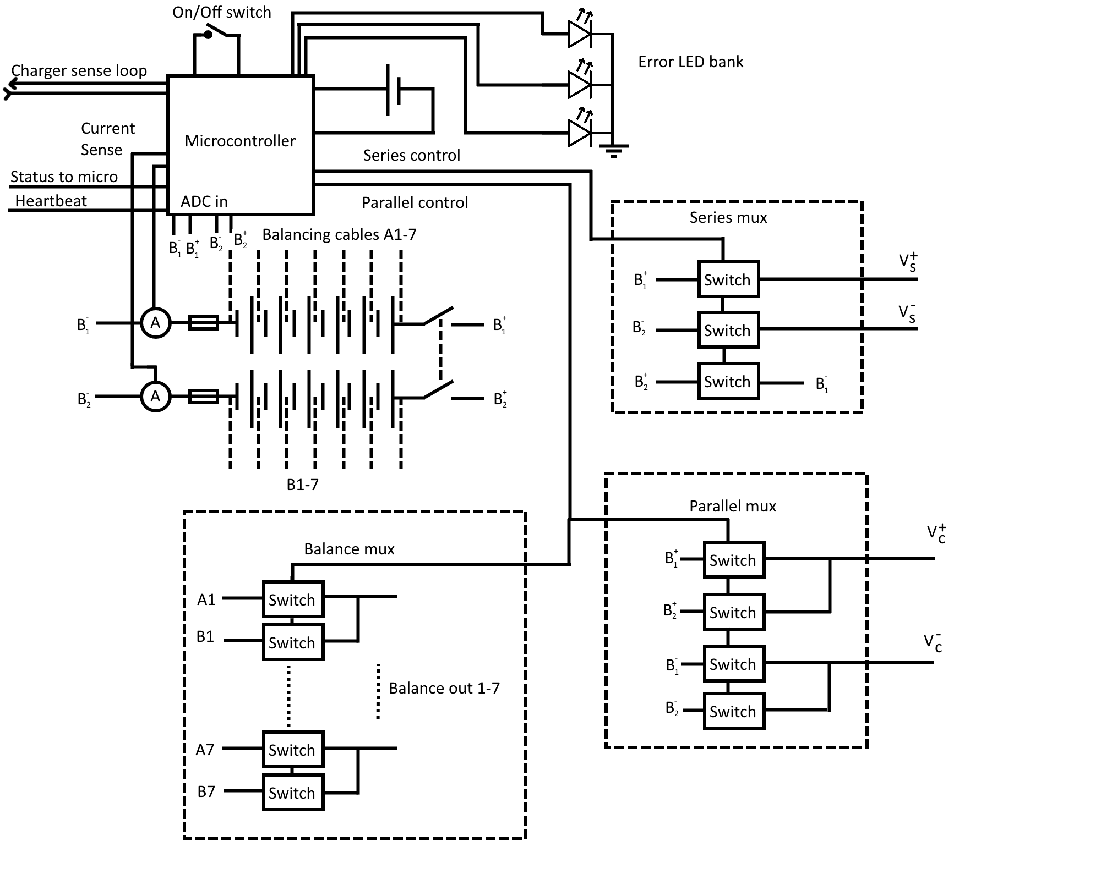

* Increase the serial comms to bus width

Capacity:

Various parameters affect the required range of the battery: it is specified to be charged once every 5 days whilst travelling an average distance of 3km a day, requiring a 15km range at full charge. On the flat, energy usage is estimated to be in the order of 10Wh/mile (where does this come from) – however, as a typical route is expected to contain gradients of up to 15%, the energy consumption rises to an average of 19.7Wh/mile (37Wh per daily commute). For a charge frequency of once every 5 days, a minimum capacity of 180Wh is needed. As outlined in the feasibility report, lithium polymer is the optimal battery technology for this application, with greater gravimetric energy density than other battery types. To provide the required 360Wh, the battery pack therefore would weigh approximately 2.4kg – this is a small enough load for the board to handle comfortably. The minimum energy requirement for a week’s usage was determined at approximately 180Wh – however to achieve better lifespan and provide for margin of error, the battery pack has a capacity 360Wh. This allows for an average depth of discharge of 50%, (rising to 60% with heavy usage), with each battery still holding half of its energy stored before it is recharged.

Graph of DoD here

MAKE IT MORE PROFFESIONAL SOUNDING The large capacity of the battery allows it to operate without running it flat during normal usage. High discharge levels reduce battery capacity significantly after approximately 100 cycles, severely limiting both range and battery service life. A DoD of 60% enables a theoretical lifespan of 2000 cycles, compared 300 at 100%. Due to the high current and voltage on the battery, these theoretical values will drop significantly, indicating that a DoD of 60% would be preferable as there is a significantly greater factor of safety at this discharge than when running the battery flat.

Charging:

BETTER START Due to the large battery capacity required in this application, charging becomes a significant design problem. As a large energy store is involved, the charging process must be carefully controlled not only to provide the large energy quantities, but also to prevent both damage to the battery and harm to the user.

There are various dangers associated with charging lithium polymer batteries due to lithium’s highly reactive nature: overcharging can lead to catastrophic failure in the form of fire and explosion, whilst over-discharge can lead to the formation of whisker salt deposits within the battery. Such deposits reduce coulombic efficiency and thus capacity, as well as potentially causing permanent failure if the whiskers puncture the separator, which would lead to the battery circuitry being shorted. Both overcharging and discharging can cause CO2 off-gassing, leading to the expansion and bursting of the battery casing and allowing highly reactive battery fluid to escape. As such, various mitigations must be put in place: fuses can be installed to prevent the rate of charge/discharge from exceeding safe levels whilst a battery health monitor can be implemented to ensure that the user is aware of when the battery is no longer safe for usage. Sophisticated charging circuitry must be supplied along with a detailed user manual in order to further safeguard against overcharging - such circuitry will have the capacity to monitor the battery level and reduce/increase current flow to it accordingly. To prevent discharge, an idle mode can be implemented so that the board doesn’t consume excess power if accidentally left on outside of operation. This can be further improved by means of a mechanical isolation switch, which would prevent any power being drawn the power and control circuitry when not in use.

Due to the aforementioned BETTER WORD needed dangers, it was decided that an off-the-shelf solution would be required, as designing an appropriate charging circuit for such an application in-house was not feasible. Need to push the safety reason for no 50v This however presents another problem – as the charger we picked (ToolkitRC & URUAV M800) produces 24V and cannot handle the 50V operating voltage, the batteries must be charged in parallel though they operate in series. Thus, some means of switching between series and parallel must be implemented. Additionally, this control system must include some means of balancing the charging between the multiple cells, otherwise overall capacity may be reduced due to uneven charging. IF SPACE FLESH OUT WHY

* Charger detection – shorted pins on the connector
* Custom cable – single connector for the balance leads and power rails

Control System Overview:

Due to the complex nature of the battery’s operation within this design, a control system is required to manage it. A low-power microcontroller (the STM8L) forms the basis of this system, which consists of the four control states shown in the flow diagram. This microcontroller will monitor the health of the battery pack and switch between drive (discharge) and charging by means of the battery mux detailed within the next section. This micro will receive a heartbeat signal from the main control Arduino (see control section), which will trigger the micro’s operational state. When the board is on but not in use (e.g. rider has dismounted), the micro will be able to safely isolate the battery electronics by entering the idle state, and then conserve power by moving into the hibernate state if the board remains idle for longer than a certain period of time. This micro will be on permanently in order to continually monitor the activity and health of the battery, and as such must require sufficiently low power in order for the separate battery supply to be sufficient for the product’s entire lifespan. COIN CELL The STM8L meets this requirement, requiring drawing 100μA when operational and 10μA when in a “sleep” state, which will be the case when the controller has into hibernate phase.

* Conserve power by keeping the micro on as short as possible
* Use triggers/interrupts mostly to transition from states / trigger error states

Arduino comms

* The micro also sends periodic serial transmissions to the Arduino with battery capacity and health
* The Arduino talks to the micro with a heartbeat pulse, if the heartbeat stops then the micro drops into idle imminently

***Insert flow diagram here***

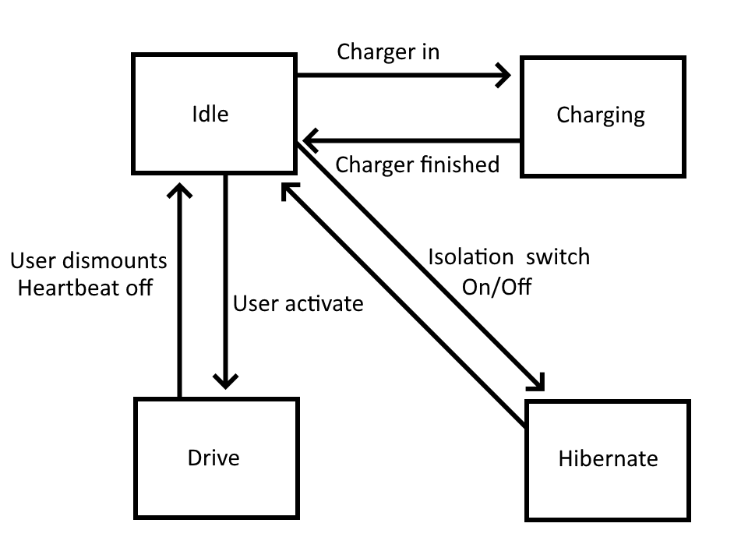

* Flow chart description
* Drive: the system is in drive mode – the main Arduino is on
* Hibernate: the system is mechanically isolated (the main breaker switches are off) (series)
* Idle: The muxes are off, but can transition into charging/drive
* Charge: the charger port is connected (parallel) and the charger mux is enabled

System transtitions

* Moving in and out of hibernate is done by moving the isolation switch (this is going to be hard)
* Moving from idle to charge happens when the charger is plugged in/out – if the battery monitor wants to stop charging it can forcefully disconnect the charger
* Moving from idle to drive happens when the user presses a button, if the battery monitor thinks that the battery pack is damaged this will trigger the LED error states
* The device drops from drive to idle by the Arduino controlling it with the heartbeat monitor

Battery Mux: what is a mux?

The battery itself has three states: charging in parallel, discharging in series and disconnected (in which there are no live terminals out of the battery system). To achieve this, a multiplexer was designed to handle switching between these states. As seen below, the mux has three main segments which receive input signals from the microcontroller. The series mux handles the discharge path (used in drive mode) which operates at 50V, 200A. When charging, the microcontroller activates the parallel control branch to the parallel mux which is rated at 25V and 10A. This signal also activates the balancing mux which handles seven low voltage, low current paths for equalising the power transferred to each battery cell. The micro can also (lots of alsos in this) isolate the battery electrically by simply disconnect? all the switches, putting the device in “Idle” mode – for safety reasons, this is the default state when not receiving the heartbeat signal. A mechanical switch operated by the user was considered for changing between the charge/discharge modes – whilst this was an attractive option due to its simplicity and relatively low cost, we considered it irresponsible from a design perspective to leave this in the user’s hands as the switching process is the most electrically hazardous part of the design. (explicit in why it breaks However, for switching the device in and out of hibernate mode, a dead-bolt style(vibration?) switch is implemented as the simpler nature of the electronics being controlled by this switch reduces the chance of damage being done (what damage are you talking about?).

* Severity of moving between hibernation states is low
* Probality is reasonably high
* Therefore we can allow using a mechanical switch

***Sam, explain how micro selects “DISCONNECTED” state***As shown by the diagram, a great many switches are required within the multiplexer, the choice of technology regarding which is significant. There are two main candidates: relays and MOSFETs. A relay is effectively an electromechanical switch, capable of handling high currents and voltages whilst also consuming a very low standby draw. MOSFETs by contrast are solid state devices that can’t withstand currents as great as that relays and consume more power on standby. Crucially however, relays are sensitive to vibration and are vulnerable to shorting or contact-welding in this scenario. MOSFETs are resistant to such mechanical issues, and as they can operate comfortably at the rated currents and voltages of the design, are better suited to this application.

Alton also complained about not using a mechanical switch so we should add a little section

* Mechanical switches were rejected as they are also prone to the same issues as the relays
* They also need to be operated by the user – (they could forget and damage the charger itself)
* They are much cheaper and simpler to design (but come with some downsides)
* They are overall less safe – which trumps there simplicity and cost
* This switch is not used very often so it can be vibration protected, and won’t cause a catastrophic failure if it is open or close

Mechanical Considerations:

Other potential hazards include mechanical damage to the battery from potential impacts, which could lead to leakage of the fluid and potential ignition should the wall be punctured – this would be secured against through the use of an external hard casing that the battery would be fitted into with additional anti-vibration measures.Such measures would include providing padding between the battery and casing wall, with sufficient venting to prevent over-heating issues.

Finally, shortage of the terminals, though unlikely, still needs consideration as this failure mode is catastrophic with high current draw leading to potential ignition. This can be easily prevented however with the use of industry standard connectors with the fuse in series with the battery, isolated contacts and sufficient water-proofing.

Possible other states

Error LED states

* Low power LEDs are used to indicate battery error states
* The LEDs form a 3 bit array that can be used to lookup error states in the handbook/manual
* The LEDs flash when the on button is pressed if the system declines to move into drive mode